Supply Chain Shaman.com

Time to Paint Outside the LInes
Posted: 07 Jul 2012 08:38 AM PDT
As a creative kid, I never wanted to paint within the lines. Did you? I found that it was just too confining. While my mother knew that the teacher’s goal was to help me develop fine motor skills, she let me race past the boundaries to make the picture my masterpiece… my expression of the day. She never forced me to paint within the lines.
As an analyst, in an attempt to explain supply chain planning to the potential buyer, I have not done as well. I have unwittingly asked supply chain leaders to paint within the lines. The origins were well intended. In an effort to better explain technologies, I defined application areas. I drew lines and boxes and defined taxonomies. I rated vendors within these frameworks. These diagrams provided order in a crazy world. This was done in an attempt to provide clarity; but today, I find what I built ten years ago too confining. However, I still see them being used. I have unknowingly constrained thinking.
The analyst community traditionally penalizes technology vendors that do not fit into “nice and neat” boxes. We unknowingly want the vendors to stay within the lines, and then ironically complain that there is no “innovation.” (Admittedly, I am part of a tough group of characters.)
Let’s take a look at history. I was part of a group at Gartner Group that put Ariba on Problem Watch in 2001 (http://www.marketwatch.com/story/ariba-rebounds-after-it-replies-to-negative-report). We predicted that this builder of procurement networks would struggle and be acquired in 2002. We were wrong, Ariba had a good run for a decade after the report predicted its demise. The company was acquired in 2012 by SAP for 4.3 billion after establishing cloud-based networks for procurement. Cloud and networks were new concepts in 2001. They went to the cloud and painted outside the lines.
In a similar way, I feel that this bias limited the potential of vendors like Kinaxis. The overzealous coverage of i2 Technologies by AMR Research did not allow for others to shine, and Kinaxis did not fit into the “nice and neat” boxes. Quite frankly, understanding the value proposition of new technology vendors is hard. As analysts we have to sort through a lot of hype to find out what is real. Many come and go. It took me two years to understand the value proposition of Terra Technology. I was dubious when I first encountered the founders of Open Ratings that was then bought by Dun and Bradstreet. I was also skeptical when I first met the founder of Enterra Solutions. All of these vendors have had the courage to paint outside the lines.
Recently, I was visiting the offices of a major ERP/APS technology provider. They were proud to show me some new software that ran the old definitions of supply chain planning faster in memory. They thought that I would be excited, and were a bit surprised when I was not. Initially the meeting was contentious, then they mellowed when I asked them, like I ask you, to paint outside the lines. As I drew what I think is the future of supply chain planning, the drawings were contested by the group; but as they left the room, they took pictures of the drawings before they erased the board for the next meetings. They wanted to be sure that they had them.
In this blog, I want to give my readers permission, even encouragement, to paint outside the lines. The traditional definitions of supply chain planning are being redefined. The business problem has changed and new technologies enable new approaches. With the evolution of Big Data systems, new forms of analytics and greater power of in-memory processing, old architectures are antiquating. I believe that it is time for the old and traditional architectures to give way, and for gals like me to try to paint new lines and boxes within new frameworks. In this blog, I contrast the old and new views.

An Aside
As I have traveled the country and talked about the exciting things we are cooking up at Supply Chain Insights , I have had a lot of push back on the name Supply Chain Insights. This happens most often in Europe or in discussions with Indian system integrators.
As I describe the research agenda of my new company, and the aggressive publishing schedule, their standard comment is “You are covering so much more than supply chain. Why did you name the company with such a limiting definition by using the term supply chain?”
I smile. And then I respond, “I believe that we should be discussing how to connect the customer’s customer to the supplier’s supplier. I believe that we should not be marketing driven, but market driven. I believe that the vertical processes of sales, marketing, logistics, manufacturing and procurement need to cede and give way to the building of outside-in horizontal processes. The traditional views are too limiting. We have built inflexible inside-out processes that need to transition to outside-in processes to improve sensing and drive an intelligent response. We need to start with the ends of the supply chain (commercial and procurement teams) and work back. This is my mission.” They smile. Sometimes dubiously….
I know that it is a different world. I am painting outside of the lines again. Their world view is within functional lines that they are comfortable with. I am challenging the hard and fast lines that defined the traditional functional buyer of enterprise applications. I write for the buyer of enterprise applications that is pushing the boundaries. As a result, I will always paint outside the lines.

The Old Lines
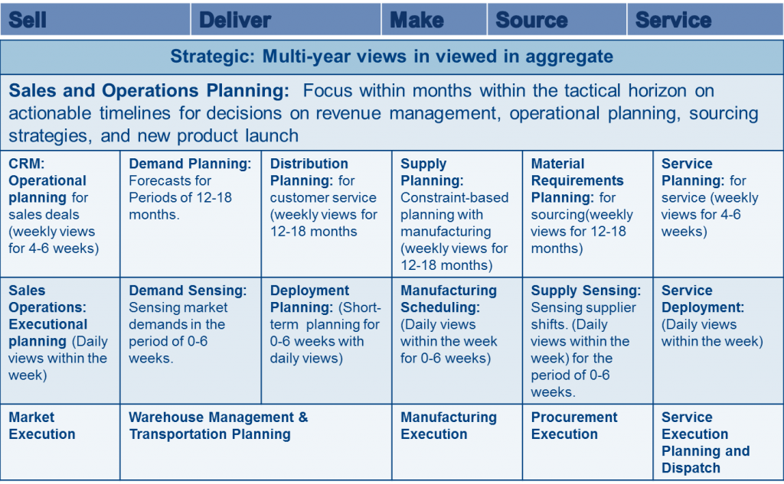The old lines of supply chain planning were hard and fast. The traditional supply chain frameworks had a strong focus on vertical process focus. Supply chain execution (SCE) was only defined as systems – transportation, warehouse management, and order fulfillment– that improved order to cash processes. Demand planning was defined tactically, but lacked an operational component. Demand sensing definitions evolved in the past five years to fill this void to replace rules-based consumption with short-term forecasting processes, but it is not sufficient. Customer Relationship Management (CRM) has never lived up to its believed potential. The ends of the supply chain –sales and procurement — are weak links, and a barrier to forging the end-to-end supply chain. We will never build strong value networks with the current definitions of enterprise applications.

My New Lines
Today, I think the processes need to start outside-in. They need to be constructed from the customer back to the supply chain within the enterprise. The focus needs to be on value-based outcomes.
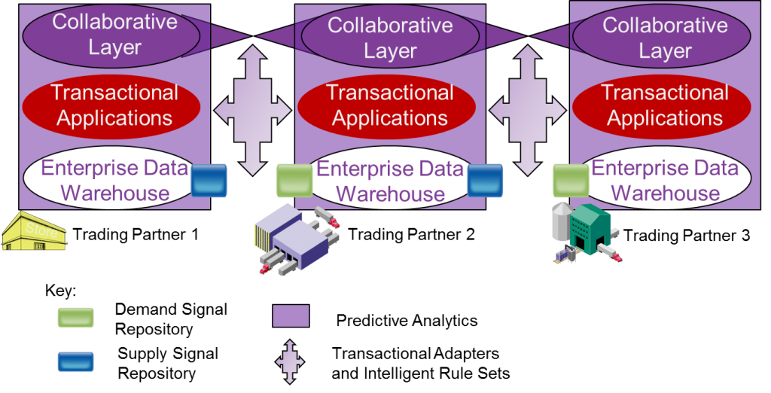Long term, I think that the architectures will have a collaborative layer, a transactional layer and will be enriched and supported by a new Business Intelligence (BI) architecture. Companies will also realize they need to build an inter-enterprise system of record.
The purple areas in the drawing are new forms of analytics that are evolving to help organizations better sense and respond to market shifts. I also believe that in this next decade we will see our current transactional systems (often termed ERP, CRM and SRM) become legacy applications.
Business differentiation will occur through new forms of predictive analytics and pattern recognition that will happen within the new suites of emerging applications by vendors that paint outside the lines. Look for them in the areas of sentiment analysis, natural language processing, text mining, advanced pattern recognition, rules-based ontologies, and advanced optimization techniques. I think we will get new sets of “black boxes” that will combine these techniques for the supply chain.
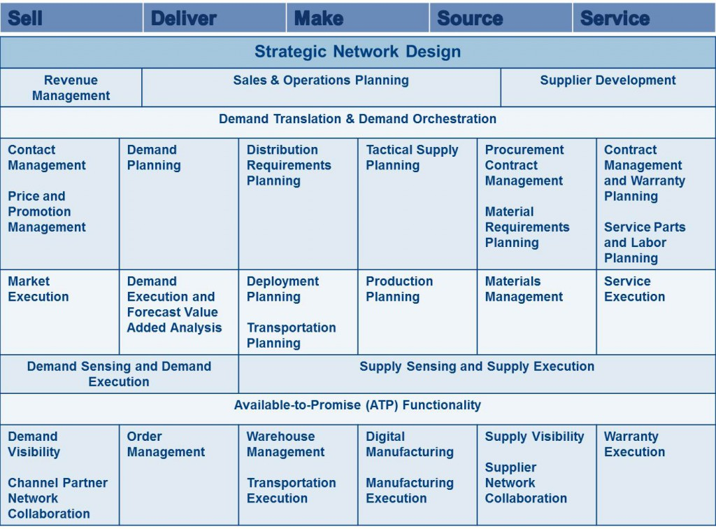Within the supply chain planning suite within the enterprise, I predict that the new world will be based on analytics. Demand signal repositories, supply signal repositories and enterprise data warehouses. There will be a shift from transactional systems to Business Intelligence (BI) architectures. BI will mean much more than rows and columns and reporting. This drawing is aspirational, it is not today’s reality.
There are eight shifts in the drawing that are a major shift from the traditional view portrayed above.
1) Shift from Vertical to Horizontal Processes. While there has been a resurgence in Sales and Operations Planning (S&OP), there is also slow momentum growing for revenue management and supplier development programs. There is slow realization that CRM and SRM architectures are not sufficient to drive compliance and orchestrate reliable networks. As a result, companies are beginning to invest in three, not one, horizontal processes (definitions listed below): revenue management, S&OP, and Supplier Development.
2) Demand Translation and Demand Orchestration. With the increasing volatility of commodity markets, companies need to quickly translate demand implications of channel strategies and orchestrate them bidirectionally market-to-market through demand orchestration. In demand orchestration, advanced analytics are used to rationalize customer, product and material strategies to predicted shifts in commodity markets against market potential. An early example of this type of functionality is Signal Demand in the process industries. The work by Cargill Beef and Fonterra are case studies to follow closely.
3) Management of the Supply Chain Planning Market -to-Market from Contract-to-Contract. Contract management has not played heavily in supply chain planning. With the slowing growth and increased market volatility, this is changing. In the future, I believe that text mining and natural language processing will be used to translate contract terms to demand orchestration processes. Early work in this area is seen in contract compliance by Enterra Solutions’ work at Conair and Newell Rubbermaid.
4) Completion of the Demand Management Footprint. Traditional demand planning was defined as a tactical planning process with no tie to market execution. As demand sensing capabilities are replacing rules-based consumption, there is the evolution of a demand execution footprint complete with forecast value-added analysis (FVA) to evaluate continuous improvement programs in demand management. Look for new footprints in this area from SAS and Terra Technology.
5) Building of Demand and Supply Sensing Capabilities. The use of unstructured and structured data to sense demand and supply capabilities will first evolve through Big Data Services and then be integrated with enterprise data repositories. Bazaarvoice’s listening service for ratings and reviews and Dun & Bradstreet’s listening for supplier performance are early examples of this type of service.
6) New Capabilities for Demand and Supply Execution. Long term, both demand and supply execution and functionality for demand and supply networks will be constructed from the outside-in. This is where the average company will first encounter Big Data concepts as they try to fuse streaming data, geolocation and mobile data, and large transactional data sets. Kinaxis’ work in in-memory processing of supply data is an early form of this functionality.
7) Closed Loop Processes for Demand and Supply. Large scale parallel processing and advanced optimization and new predictive analytics techniques will allow companies to sense, respond and evaluate. This will evolve to listen, test and learn strategies for both demand and supply over the course of the next five years.
8) Building of Supply and Demand Networks. The traditional programs for Vendor Managed Inventory (VMI) and Supplier Managed Inventory (SMI) systems have been implemented, but never tightly integrated because the enterprise data models were inside-out not outside-in. As the enterprise architectures are redefined, VMI and SMI will become tightly integrated and enriched with unstructured data like quality, return, warranty and social data. This will redefine demand and supply visibility.

Where are you Drawing the Lines?
Supply chain architectures are in flux. I would love to know your thoughts. While I hesitate to replace one set of boxes and lines with another, I know no other way to communicate the changes. However, this does not mean that you or your teams need to paint within the lines. All I know for sure is that the traditional architectures are too constraining and no longer meet the business need; and that new forms of technologies allow us to rethink how companies can draw the lines.
OK, enough from me on a sizzling July afternoon. Drop me a note and let me know your thoughts. I would love to hear from you on where you are drawing the new lines.
Next week, I am attending the SAP Base Camp followed by a full agenda to work with clients on these concepts in strategy workshops. I have made good progress on my new reports. I should publish four by Friday next week. Things are exciting in my new company. We appreciate your support of Supply Chain Insights.

Definitions: For those that have not read some of my fundamental writing on these topics, for clarity, I list the definitions of the terms below.
- Demand Sensing: Shortening the time to sense “true” market data to understand “true” market shifts in the demand response. This is in contrast to the use of order-to-shipment data that can have 1-3 weeks latency in translating “true” market demand.
- Demand Shaping: The use of techniques to stimulate demand. This includes new product launch, price and revenue management, assortment, merchandising, placement, sales incentives and marketing programs.
- Demand Translation: The translation of demand outside-in from the market to each role within the organization. Recognizing that the requirements for distribution, manufacturing and procurement are different.
- Demand Orchestration: The process of making trade-offs market-to-market based on the right balance of demand risk and opportunity.
- Demand Shifting: The shifting of demand from one period to another through advanced shipments, and moving more products into the channel without stimulating base demand.
- Revenue Management: The process of stimulating demand through demand shaping efforts and carefully managing payment capture to ensure that the changes in payment terms do not result in deductions. Evaluation of the effectiveness of demand shaping programs through sales analytics.
- Supply Sensing: The use of unstructured and structured data to sense supplier failure and pending supply shortages.
- Supplier Development: The process of supplier selection, training, onboarding and adherence to supplier policies. Supplier development programs have increased in importance to accelerate innovation, improve supply and ensure compliance to corporate social responsibility initiatives.

